When we want to know about the income status about the immigrants in the U.S, we chose the wage/salary income(WAGP) variable in the past year. We can divide them into nine class:

Class 1:0 (no payment)

Class 2: 0-20000 (0 is not included)

Class 3:20000-40000

Class 4: 40000-60000

Class 5: 60000-80000

Class 6: 80000-100000

Class 7: 100000-150000

Class 8: >150000

Class 9: no record

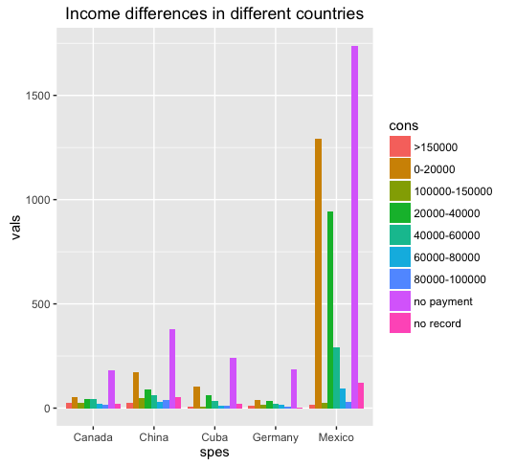

From above picture, we can say that in the typical five countries, immigrants who have no payment take the most percentage. And in Mexico and China, immigrants who are only paid low money (0-20000) ranks seond.

Or we can choose an easier way: just use their wage divided by 10000 to represent the relative differences between wages. And in this way can we make the interactive plot.